Create a HTML document that has five frames . There must be two rows of frames, the first with three frames and other with two frames . The frames in the first row must have equal width . The left frame in the second row must be 50 percent of the width of the display. Each of the frames in the top row must display a document that has a form.The left top frame must have two text boxes each 30 characters wide labelled Name and Address. The middle top frame must have five radio buttons with color name labels.The right top frame must have check boxes labeled with 4 kinds of equipment such as cd player, ac, fridge,tv. The two bottom frames must have images of two different cars. The top row frame must use 20 percent of the height of the display.

**Main file**

<html>

  <head>

    <title>Frames Exercise</title>

  </head>

  <frameset  rows="20%,*">

      <frameset cols="*,*,*">

        <frame src="frame1.html" name="frame1">

        <frame src="frame2.html" name="frame2">

        <frame src="frame3.html" name="frame3">

      </frameset>

      <frameset cols="50%,*">

            <frame src="frame4.html" name="frame4" >

            <frame src="frame5.html" name="frame5">

      </frameset>

  </frameset>

</html>

**Frame1 file**

<html>

  <body>

    <form action="">

      <label for="Name"

        >Name:<input type="text" name="Name" size="30" />

      </label>

      <br /><br />

      <label for="Address"

        >Address:<input type="text" name="Address" size="30" />

      </label>

    </form>

  </body>

</html>

**Frame2 file**

<html>

  <body>

    <form action="">

      <label for="color"

        ><input type="radio" name="color" value="Red" />Red</label

      >

      <br />

      <label for="color"

        ><input type="radio" name="color" value="Green" />Green</label

      ><br />

      <label for="color"

        ><input type="radio" name="color" value="Blue" />Blue</label

      ><br />

      <label for="color"

        ><input type="radio" name="color" value="Black" />Black</label

      ><br />

      <label for="color"

        ><input type="radio" name="color" value="White" />White</label

      ><br />

    </form>

  </body>

</html>

**Frame3 file**

<html>

  <body>

    <form action="">

      <label for="equipment"

        ><input type="checkbox" name="equipment" value="Laptop" />Laptop</label

      >

      <br />

      <label for="equipment"

        ><input type="checkbox" name="equipment" value="Gaming console" />Gaming

        console</label

      ><br />

      <label for="equipment"

        ><input type="checkbox" name="equipment" value="Smart Tv" />Smart

        Tv</label

      ><br />

      <label for="equipment"

        ><input type="checkbox" name="equipment" value="Air conditioner" />Air

        conditioner</label

      ><br />

      <label for="equipment"

        ><input type="checkbox" name="equipment" value="Home theatre" />Home

        theatre</label

      ><br />

    </form>

  </body>

</html>

**Frame4 file**

<html>

  <body>

    <img style="width: 100%; height: 80%;" src="img1.jpg" alt="" />

  </body>

</html>

**Frame5 file**

<html>

  <body>

    <img style="width: 100%; height: 80%;" src="tesla.jpg" alt="" />

  </body>

</html>

**Output**

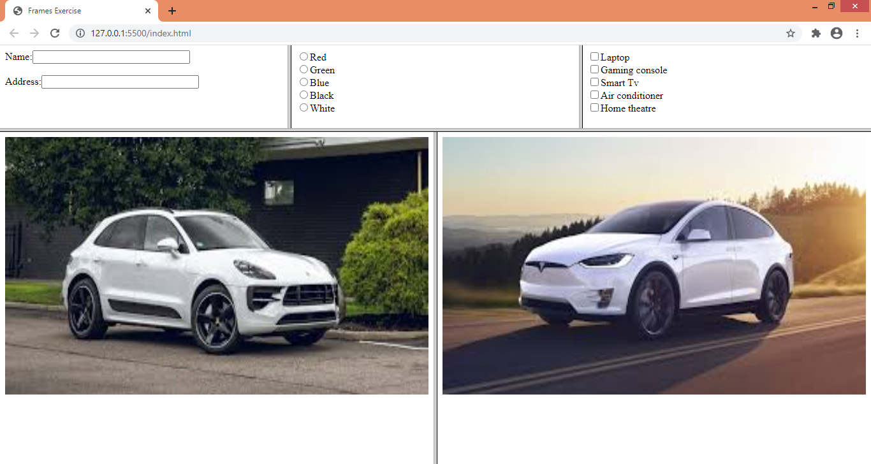

1. Write HTML code to display your biodata consisting of your PHOTO, EDUCATIONAL QUALIFICATIONS in tabular format, PERSONAL DETAILS that include name,age ,address,phone no and email and PROGRAMMING LANGUAGES KNOWN in list form .Use frames consisting of banner of your name, left frame showing the links to different parts of your biodata.

**Main file**

<html>

  <head>

    <title>Frames Exercise</title>

  </head>

  <frameset  rows="20%,*">

      <frameset cols="*,*,*">

        <frame src="frame1.html" name="frame1">

        <frame src="frame2.html" name="frame2">

        <frame src="frame3.html" name="frame3">

      </frameset>

      <frameset cols="50%,*">

            <frame src="frame4.html" name="frame4" >

            <frame src="frame5.html" name="frame5">

      </frameset>

  </frameset>

</html>

**Frame1 file**

<html>

  <body>

    <h1>Chaitanya Chanekar</h1>

  </body>

</html>

**Frame2 file**

<html>

  <body>

    <ul>

      <li><a href="photograph.html" target="display">Photograph</a></li>

      <li><a href="Detail.html" target="display">Personal Details</a></li>

      <li>

        <a href="qualification.html" target="display"

          >Educational Qualification</a

        >

      </li>

      <li>

        <a href="pLang.html" target="display">Programming Languages Known</a>

      </li>

    </ul>

  </body>

</html>

**Frame3 file**

<body></body>

**Photograph link page**

<html>

  <body>

    <img

      src="profile.jpg"

      alt=""

      style="width: 100px; height: 100px; margin: 20px; padding: 20px;"

    />

  </body>

</html>

**Details link page**

<html>

  <body>

    <label for="Name">Name: Chaitanya Chanekar</label> <br />

    <label for="age">Age: 18</label> <br />

    <label for="Address">Address: Deulwada Parcem Pernem Goa. 403512</label>

    <br />

    <label for="PhoneNumber">Ph.Number: 987654321</label> <br />

    <label for="email">Email: chaitanya.chanekar2292@gmail.com</label> <br />

  </body>

</html>

**Qualification link page**

  <body>

    <h3>Education Qualification</h3>

    <ul>

      <li>SSC - Fr Agnel High School Pilar</li>

      <li>

        Diploma in Computer Engineering - Agnel Polytechic Verna. (ongoing)

      </li>

    </ul>

  </body>

</html>

**Programming languages known link page**

<html>

  <body>

    <h3>Programming Languages</h3>

    <ul>

      <li>C Language</li>

      <li>JAVA</li>

      <li>Javascript</li>

      <li>PHP</li>

    </ul>

  </body>

</html>

**Output**

